Currency Converting Application

Sanduni Rathnapriya

(Undergraduate student University of Peradeniya BSc Hons in Applied Science)

15 June 2024

1. **Executive Summary**

I plan to create a simple web page that allows users to convert currency values into their preferred currency without having to perform complex calculations. This web page aims to be highly user-friendly, making currency conversion easy and accessible for everyone. I will do my best to ensure the interface is intuitive and straightforward, providing a valuable tool for those needing to convert currency amounts quickly and accurately.

1. **Introduction**
   1. **Overview**

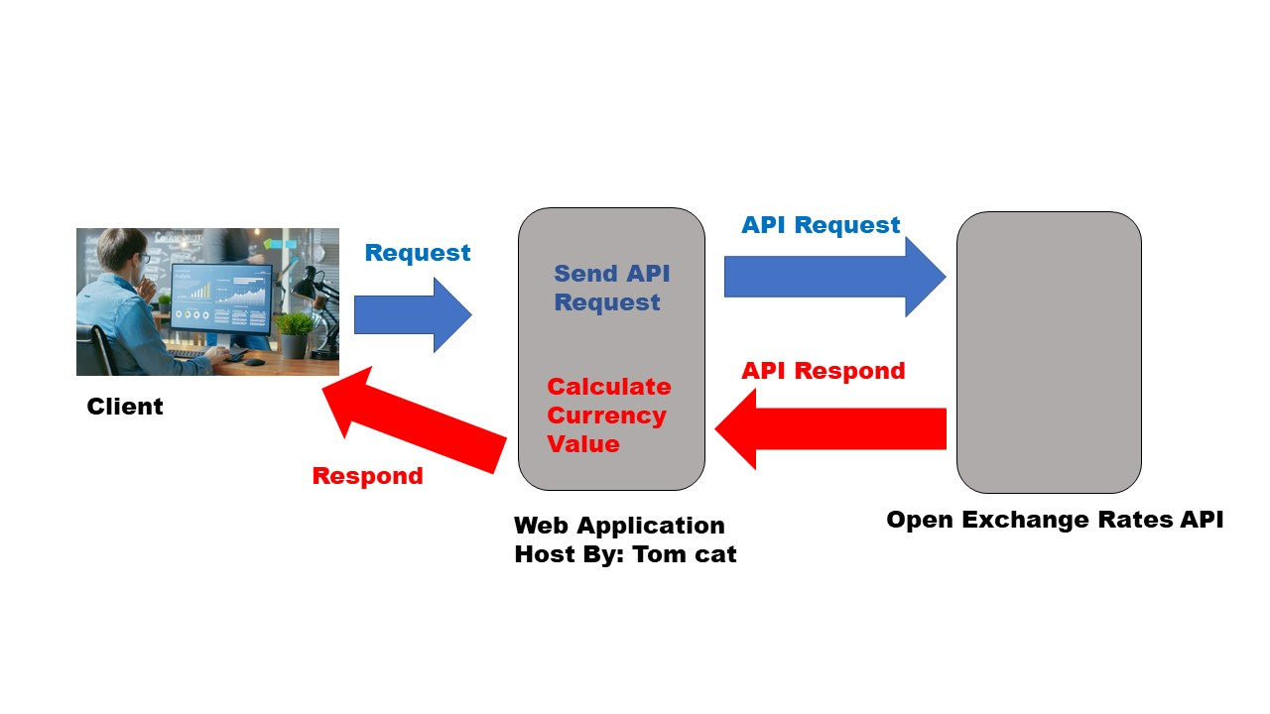

**Image 2.1**

This image 2.1 is showing the project diagrammatically. The technical background will be explained in Chapter 8.

* 1. **Objective**
* Create user friendly front end
* Create Connection between API and web application
* Create converting calculations
* Create respond
* Deploy the web application
  1. **Scope**

This is a simple web application that I created for educational purposes. I hope to learn about web applications, web services, and APIs from this project.

1. **Project Description**
   1. **Front end**

Image 3.1 is given web page front end view.

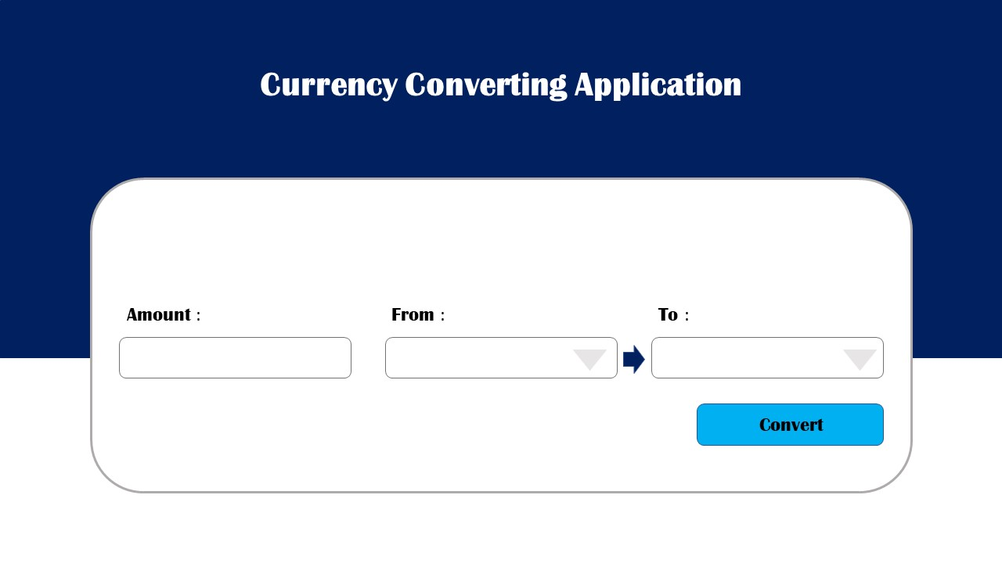

**Image 3.1**

I used a simple page for this web application. The user can easily enter a currency amount in the amount field, select their current currency type, choose the desired currency type for conversion, and simply press the convert button.

After Pressing convert button front end look like image 3.1 given below.

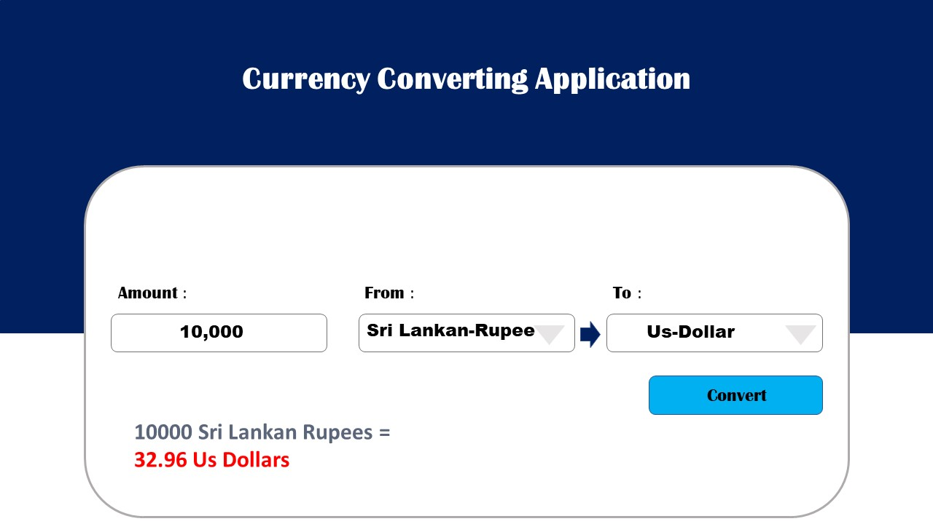

**Image 3.2**

* 1. **How Web Application Works**

Enter value and press enter

Web Application

Open Exchange Rates API

Web Application

Calculate value

Give Current Values for currency

Show on front end

* 1. **Technical Specifications**

|  |  |  |
| --- | --- | --- |
|  | Feature | Technology |
|  | Programming language | Java, Html, CSS |
|  | Libraries | java servlet,web features,applet and ajax |
|  | currency exchange rate API | Open Exchange Rates |
|  | IDE | IntelliJ IDE |
|  | Plate form | Web application |

1. **Development plan**
   1. **Project Phases**

* Planning and Requirement Analysis
* Design
* Implementation
* Testing
* Deployment
  + Study about deployment system
  + Deployment
  1. **Time line**

Planning and Requirement Analysis, Design

|  |  |  |  |  |  |  |  |
| --- | --- | --- | --- | --- | --- | --- | --- |
| Date | 06/15 | 06/16 | 06/17 | 06/18 | 06/19 | 06/20 | 06/21 |
| Work |  |  |  |  |  |  |  |

Study about deployment

deployment

Connect and testing

Back-end coding

Front end Coding

Understanding about back-end coding

1. **Conclusion**
2. **References**

Get Front end Idea:

<https://www.xe.com/currencyconverter/>

google currency converter

Get idea about web sites:

From youtube

Get Idea about how API works:

Learn about Currency API:

From chat gpt

Learn about web servlet:

From chat gpt